Day 21 – Time Series Fundamentals

What is Time Series Data?
Time series data is a sequence of data points collected or recorded at successive points in time, usually at uniform intervals — seconds, minutes, hours, days, months, or years. Simply put, it is any data that is tagged with a timestamp. Examples include daily stock prices, hourly temperature readings, monthly sales figures, or yearly population counts.

Key Concepts in Time Series Data Analysis

1. Patterns
A pattern in time series data refers to any regular or repeated behavior over time. It’s a broad term that covers trends, seasonality, and cycles, but also other repeated signals.
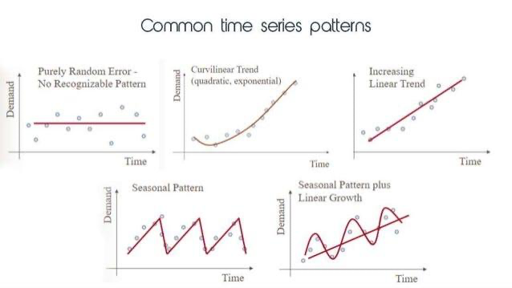
Example: If website visits spike every weekday and drop on weekends, that’s a pattern indicating user behavior varies by day of the week.

2. Trend
A trend is a long-term increase or decrease in the data over time. It represents the overall direction the data is moving, ignoring short-term fluctuations.
Example: If monthly sales figures steadily increase over several years due to business growth, that upward movement is a positive trend.
​​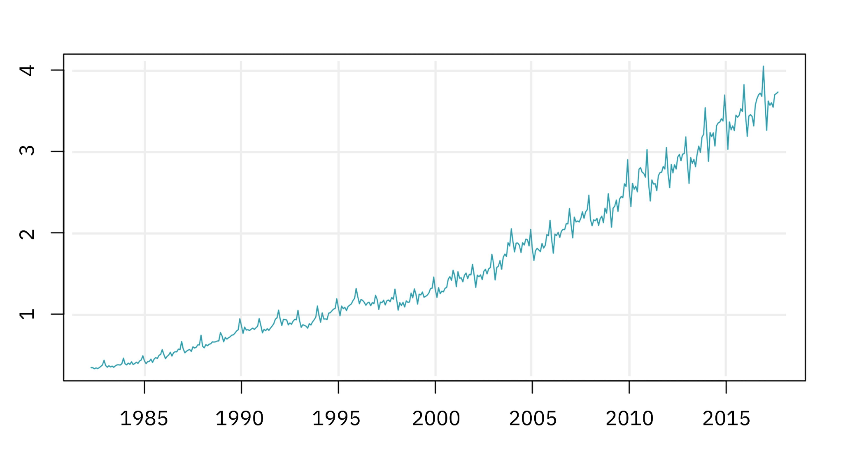

3. Seasonality
Seasonality refers to regular, predictable fluctuations that occur at fixed calendar intervals due to seasonal factors like time of day, day of week, month, or quarter.
Example: Retail sales often peak every December because of holiday shopping — this yearly pattern is seasonality.
​​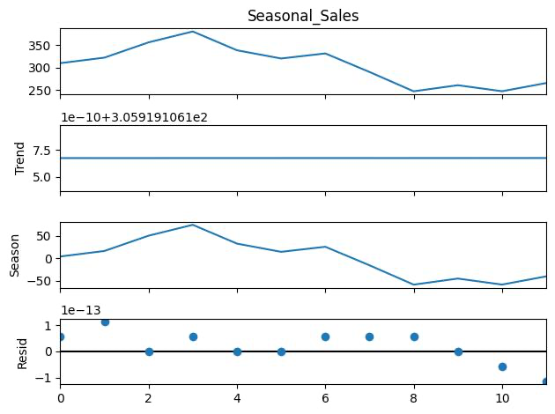

4. Cycles
Cycles are fluctuations that repeat over longer, irregular periods, often influenced by economic or business conditions. Unlike seasonality, cycles do not follow a fixed calendar schedule.
Example: An economic recession cycle that lasts several years but doesn’t occur on a strict timetable is a cycle.

5. Noise
Noise is the random, irregular variation in the data that cannot be explained by trends, seasonality, or cycles. It’s the “background static” that can obscure the underlying signals.
Example: A sudden spike in sales due to an unexpected one-day promotion or a supply disruption causing a temporary dip is noise — these are random events that don’t follow a pattern.
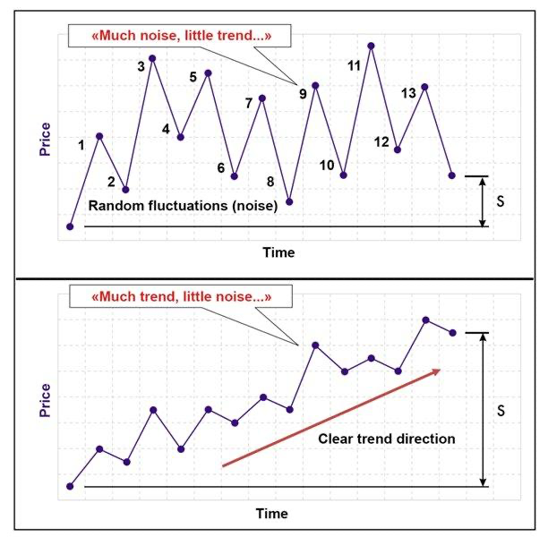
BUSINESS USECASE:

1. Demand Forecasting
- Retail predicts product demand
- Avoids overstock / stockouts
- Used by Walmart

2. Weather Prediction
- Rainfall forecasting for cities like Chennai
- Helps in flood control, agriculture

3. Stock Market Analysis
- Price prediction
- Volatility analysis
- Used by traders working with NASDAQ

4. Energy Consumption
- Predict electricity demand
- Avoid power cuts

5. Traffic & Ride Demand
- Uber surge pricing
- Peak hour prediction by Uber

